**LAPORAN PRAKTIKUM PENGOLAHAN CITRA DIGITAL**

**16. BINARY MORPHOLOGICAL IMAGE**

**PROCESSING**



**Disusun oleh :**

**Nama : Garcia Bryan Farrel**

**NPM : 2327250026**

**Kelas : IF41**

**PROGRAM STUDI INFORMATIKA**

**FAKULTAS ILMU KOMPUTER DAN REKAYASA**

**UNIVERSITAS MULTI DATA PALEMBANG**

**2024**

**TUTORIAL : BINARY MORPHOLOGICAL IMAGE**

**PROCESSING**

**Goal**

The goal of this tutorial is to learn how to implement the basic binary morphological

operations in MATLAB.

**Objectives**

* Learn how to dilate an image using the imdilate function.
* Learn how to erode an image using the imerode function.



**FIGURE 16.1.** Example of using top-hat and bottom-hat filtering for contrast improvement: (a) input image; (b) output image.

* Learn how to open an image using the imopen function.
* Learn how to close an image using the imclose function.
* Explore the hit-or-miss transformation using the bwhitmiss function.

**Procedure**

1. Load and display the blobs test image.



**Dilation**

1. Create a 3×3 structuring element with all coefficients equal to 1.



1. Perform dilation using the generated SE and display the results.



|  |
| --- |
|  |
|  |

**Question 1** What happened when we dilated the image with a square 3×3 SE?

|  |  |
| --- | --- |
|  |  |

Let us now see what happens when using a SE shape other than a square.

1. Create a 1 × 7 SE with all elements equal to 1 and dilate the image.

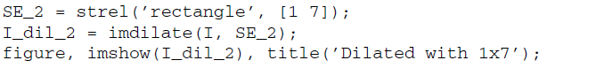

|  |  |
| --- | --- |
|  |  |

**Question 2** What is the difference in results between the dilation using the 3 × 3 SE and the 1 × 7 SE?

|  |
| --- |
| 3×3 memperluas objek dalam semua arah (atas, bawah, kiri, kanan) secara seimbang. Hasilnya objek tampak membesar.  SE 1×7 hanya memperluas objek secara horizontal. Hasilnya objek akan melebar ke samping, tetapi tidak bertambah tinggi. |

**Question 3** How would the results change if we use a 7 × 1 SE? Verify your prediction.

|  |  |
| --- | --- |
| 7x1 meperluas objek secara vertikal. |  |

**Question 4** What other SE shapes does the strel function support?

|  |
| --- |
| Fungsi strel di mendukung berbagai bentuk structuring element (SE). Seperti disk, diamond, square, rectangle, dan lain lain. |

**Erosion**

The procedure for erosion is similar to that for dilation. First, we create a structuring element with the strel function, followed by eroding the image using the imerode function. We will use the same two SEs already created in the previous steps.

1. Erode the original image with a 3 × 3 structuring element and display the results.

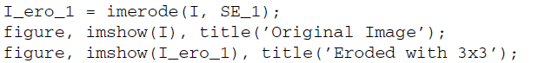

1. Erode the original image with a 1 × 7 structuring element.



|  |
| --- |
|  |
|  |

**Question 5** What is the effect of eroding the image?

|  |
| --- |
| Objek menyusut dari sisi luar. Objek kecil bisa hilang sepenuhnya jika ukurannya lebih kecil dari SE. |

**Question 6** How does the size and shape of the SE affect the results?

|  |
| --- |
| Ukuran dan bentuk structuring element sangat memengaruhi bagaimana objek dikikis. Ukuran SE semakin besar akan membuat banyak yang terkikis. |

**Opening**

1. Perform morphological opening on the original image using the square 3 × 3 SE created previously.

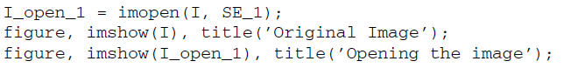

|  |
| --- |
|  |
|  |

**Question 7** What is the overall effect of opening a binary image?

|  |
| --- |
| Menghilangkan objek kecil yang tipis. |

1. Compare opening with eroding.

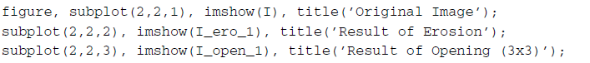

|  |
| --- |
|  |
|  |

**Question 8** How do the results of opening and erosion compare?

|  |
| --- |
| Erisoin membuat semua objek mengecil sehingga yang sudah kecil jadi menghilang.  Sedangkan Opening menghilangkan objek kecil yang tipis. |

1. Open the image with a 1 × 7 SE.



|  |
| --- |
|  |
|  |

**Question 9** How does the shape of the SE affect the result of opening?

|  |
| --- |
| Gambar horizontal menjadi hilang. |

**Closing**

1. Create a square 5 × 5 SE and perform morphological closing on the image.

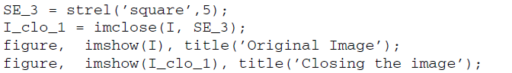

|  |
| --- |
|  |
|  |

**Question 10** What was the overall effect of closing this image?

|  |
| --- |
|  |

1. Compare closing with dilation.

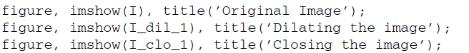

**Question 11** How does closing differ from dilation?

|  |
| --- |
| Closing mengisi lubang kecil. Sedangkan dilation yang hanya memperbesar. |

**Hit-or-Miss Transformation**

The HoM transformation is implemented through the bwhitmiss function, which takes three variables: an image and two structuring elements. Technically, the operation will keep pixels whose neighbors match the first structuring element, and will also keep any pixels whose neighbors do not match the second structuring element. This justifies the name of the operations: a hit for the first structuring element or a miss for the second structuring element.

Normally we would use strel to generate the structuring element; but in this case, we are not simply generating a matrix of 1s. Therefore, we will define the structuring elements manually.

1. Close any open windows.
2. Define the two structuring elements.

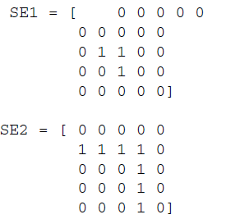

1. Apply the HoM operation on the original image.

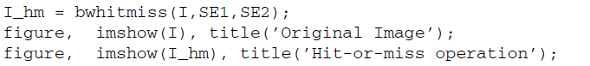

|  |
| --- |
|  |
|  |

**Question 12** What was the result of applying the HoM operation to the image

with the given structuring elements?

|  |
| --- |
| Hasil dari operasi Hit-or-Miss adalah sebuah citra biner yang menandai lokasi pola spesifik dalam gambar. |

**Question 13** How could we define the structuring elements so that the bottom left corner pixels of objects are shown in the result?

|  |
| --- |
| Untuk mendeteksi sudut kiri bawah dari suatu objek dalam citra biner, kamu bisa mendefinisikan structuring Menggunakan Dua Structuring Elements seperti (SE1 dan SE2)  SE1: menunjukkan piksel objek yang membentuk sudut kiri bawah.  SE2: menunjukkan area di sekitar sudut yang harus kosong (0). |

The bwhitmiss function offers a shortcut for creating structuring elements like the one above. Because the two structuring elements above do not have any values in common, we can actually use one array to represent both structuring elements.

In the array in Figure 13.19, 1 refers to ones in the first structuring element, −1 refers to ones in the second structuring element, and all 0s are ignored. This array is called an interval.

1. Define an equivalent interval to that of the two structuring elements previously defined.

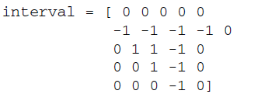



**FIGURE 16.2** Combining two structuring elements into one for the HoM transformation.

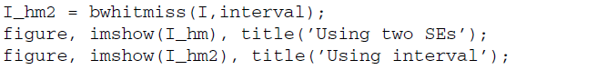

|  |  |
| --- | --- |
|  |  |

**Question 14** Will this technique work if the two structuring elements have elements in common? Explain.

|  |
| --- |
| Tidak, teknik interval tidak akan bekerja jika kedua structuring element memiliki elemen yang sama |